Level 3 Certification project- December 14, 2015
Adam Poirier – NAR 99510

Project name:

Concept:

The level 3 rocket is constructed out of 6 inch diameter blue tube, designed to house a 75mm motor with a maximum length of 1m (~3.2 feet). The booster section is 4 feet long and accommodates a three fin design with a motor mount, while the upper 4 foot section houses an electronics bay as well as compartments for drogue and main recovery systems, along with a 5:1 conical nose cone, for a total length of 128 inches. The dry weight of the rocket totals out at roughly 12.5kg.
The rocket is designed to be able to land safely without a drogue, while surviving the forces exerted by the large deceleration of the main deployment. 5/16” threaded rods run through the body, connecting directly to the shock chords; allowing for the force of recovery systems to be transferred through steel rather than the plywood bulkheads. For an added factor of safety, a small 12” drogue chute will be deployed at apogee to reduce the deceleration force when the 54” main chute is deployed.

Motor: Cesseroni M1160-P
Projected altitude: 7661 feet (simulated)
Max velocity: 259 m/s
Max acceleration: 69 m/s²
Drogue deployment: Apogee
Main deployment: 800 feet AGL

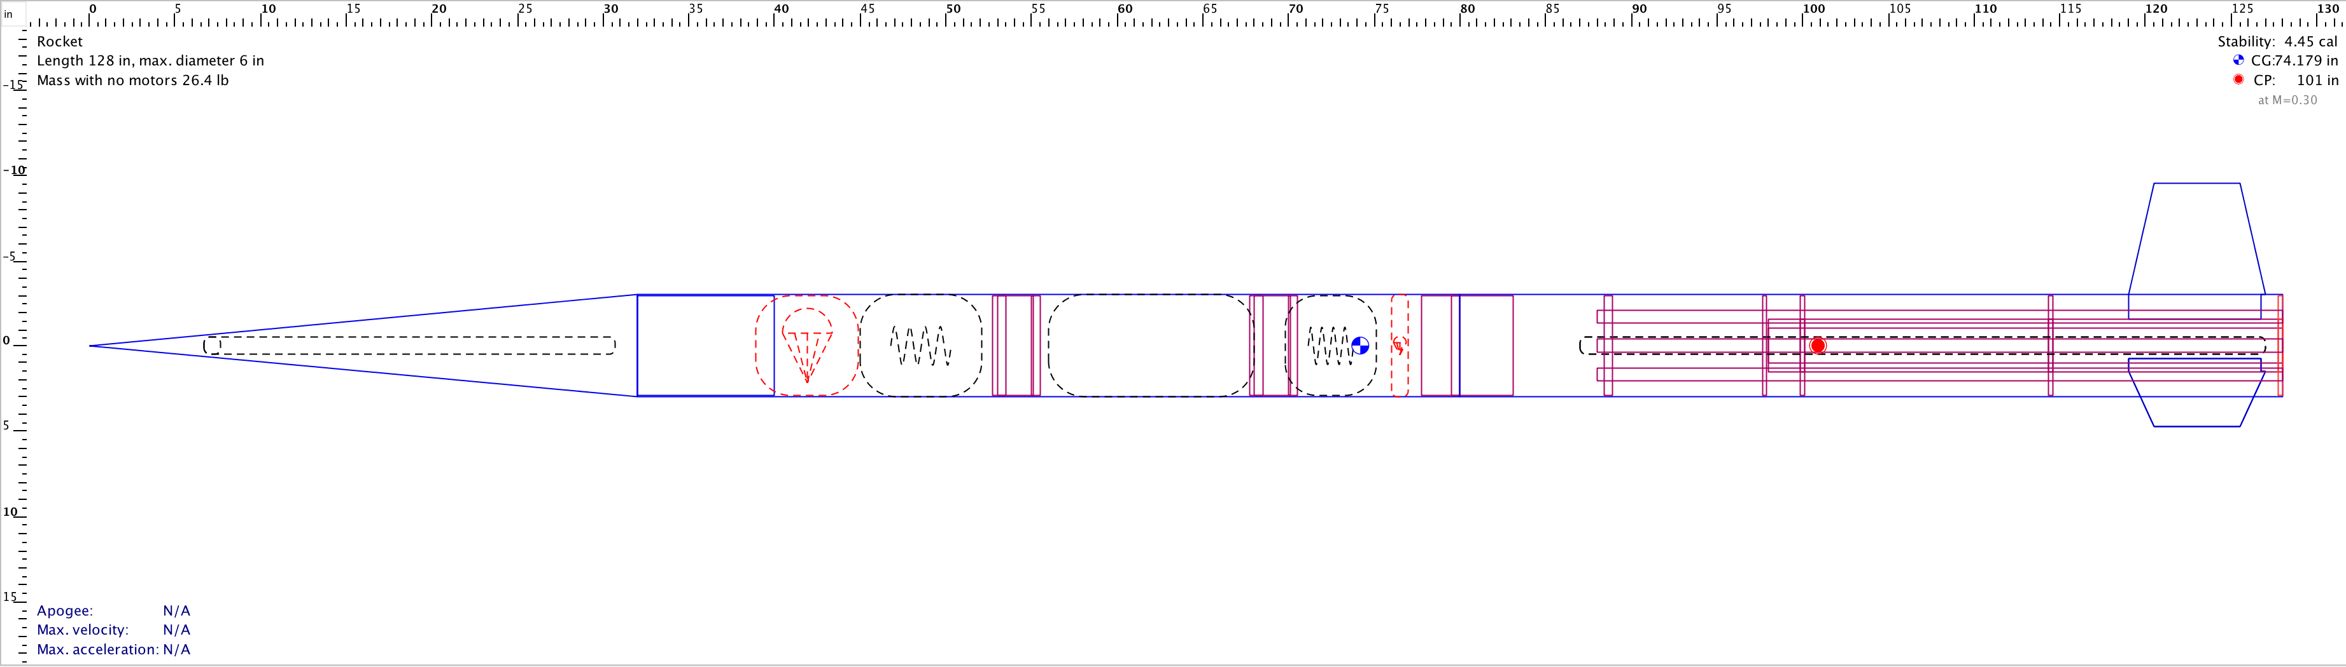
Figure 1: Dry rocket
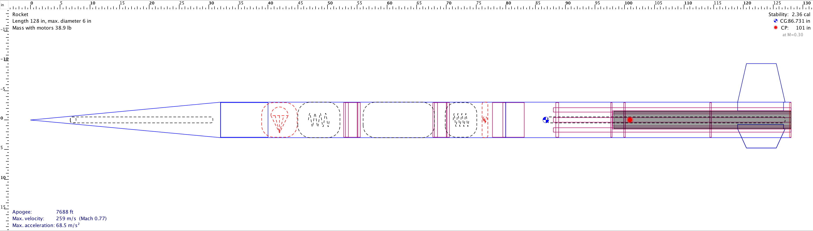

Figure 2: Rocket with M1160 motor

Fight Simulation Data:

Center of pressure: 101 inches from nose (OpenRocket V15.03)
Center of gravity: 86.73 inches from nose (OpenRocket V15.03) [With motor]
Liftoff Mass: 17.7 kg
Total impulse: 5886 Ns
Burn time: 5.1s
Thrust to weight ratio (initial): 5.47
Thrust to weight ratio (average thrust) 6.68
Stability: 2.35 calipers (at launch)
Cd: 0.6

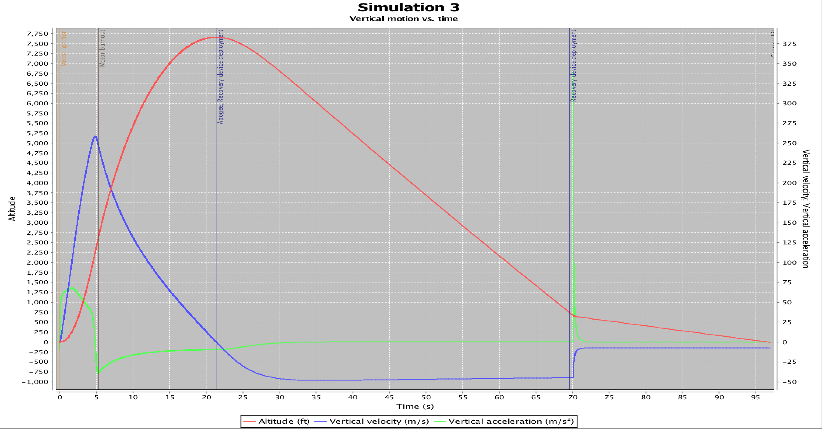
Figure 3: Vertical motion graph

Construction package

The rocket was constructed in a precise deliberate manor to ensure that it would be able to survive the stresses of an L3 rocket motor, as well as a drogueless (or very small drogue) recovery. The concept that I had while designing and building the rocket was to have every part of the body connected either through threaded steel rods or the shock chord; allowing for the rocket to withstand extreme forces without falling pray to classic construction recovery failures such as eyebolts ripping out of plywood bulkheads, or other bulkhead failures.

Rocket components:

Nose cone:
Material: Fiberglass
Shape: 5:1 Conical
Length: 31 inches
Upper body segment and payload bay:
Material: Blue Tube
OD: 6”
Length: 4 feet
E-bay (electronics bay):
Materials: 2 x 5/16th B7 steel threaded rods
¼” plywood frameworks
1/8th inch plywood mounting sleds
2x 3” bluetube couplers for e-bay mounting
¼” plywood bulkheads
5/16th x 3” B7 steel U bolts
Flight computers:
Primary: Perfect Flight StratoLogger
Secondary: Perfect Flight StratoLogger
GPS: GPS Tracking System
Radio: Big Red B radio beacon
Main parachute:
Type: FrutyChutes Iris Ultra
Diameter: 60”
Material: Nylon Toroidal
Deployment altitude: 800’ AGL
Cd: 2.2
Main and drogue:
Material: Double braided tubular rope
Thickness: ¼ inch
Tensile strength: 2,200 lbs
Length: 25’ each
Drogue parachute:
Type: Apogee standard parachute
Diameter: 12”
Material: Nylon
Deployment: Apogee
Cd: 1.5
Lower body segment:
Material: Blue Tube
Diameter: 6 inches
Length: 4 feet
Drogue attachment points (x3):
Material: Zink-plated steel
Type: 5/16th inch eyebolts with shoulders
Tensile Strength: 900 lbs
Fins (3 total):
Material: G-10 fiberglass
Thickness: ¼ inch
Overall shape: Tetrahedral
Height: 6.5 inches
Root chord: 8 inches
Tip chord: 5 inches
Sweep length: 1.5 inches
Fin tab height: 1.5 inches
Motor mount tube:
Material: Blue Tube
Diameter: 38mm
Length: 36 inches
Motor retainer:
Material: 6061 Aluminum
Type: 75mm Aeropack Flanged screw-on retainer
Mounting: 6” – 75mm thrust plate
Motor retainer to drogue attachment points:
Material: ASTM A193 Grade B7 steel
Type: 3x 5/16th inch threaded rods
Length: 38 inches
Moror mount centering rings:
Material: ¼” birch plywood
OD: 6”
ID: 78.5mm

Fin Mounting
The three fiberglass fins were dry assembled with centering rings onto the 3” motor mount tube. The centering rings were custom made and laser cut and fit in-between the fin tab and the motor mount tube, ensuring that they are exactly 120º apart from each other, as well as adding strength. Once the fins were snug into position on the tube, the assembly was inserted into the body and used as way to find the location to cut the fin slots, which were then cut with a Dremmel. The fins were inserted through the slots and aligned with the slots cut into the centering rings, and then secured into place with Rocket Epoxy and allowed to cure for 24 hours.
Once the fins were in place thick epoxy filets were applied to the external intersection between the airframe and the fins to secure them in place. Additionally three 5/16th inch steel threaded rods were inserted through the centering rings of the motor mount tube with flanged nuts threaded on either side of each centering ring. The rods stopped ½ inch before the end of the motor mount tube, where they were connected to threaded couplings up to a depth of ½ ” (half the length of the couplings) and secured with Locktite thread lock. On the other end of the steel couplings, a threaded reducer was inserted and secured with thread lock; the threaded inserts have an outer thread of 5/16th-18, and an inner thread of #10-32. The inserts serve as mounting threads for ½” #10-32 screws to attach the thrust plate to the threaded rods, and ultimately the drogue shock chord. This elaborate configuration allows for the body tube via the flanged thrust plate, to connect extremely securely to the drogue shock chord, removing the stresses from acting on the plywood centering rings.
On the other end of the shock chord is connected to a 3/8” eyebolt that screws directly into the motor casing. A quicklink and a swivel are tied in the shock chord to prevent the eyebolt from unscrewing due to vibrations and parachute movements.

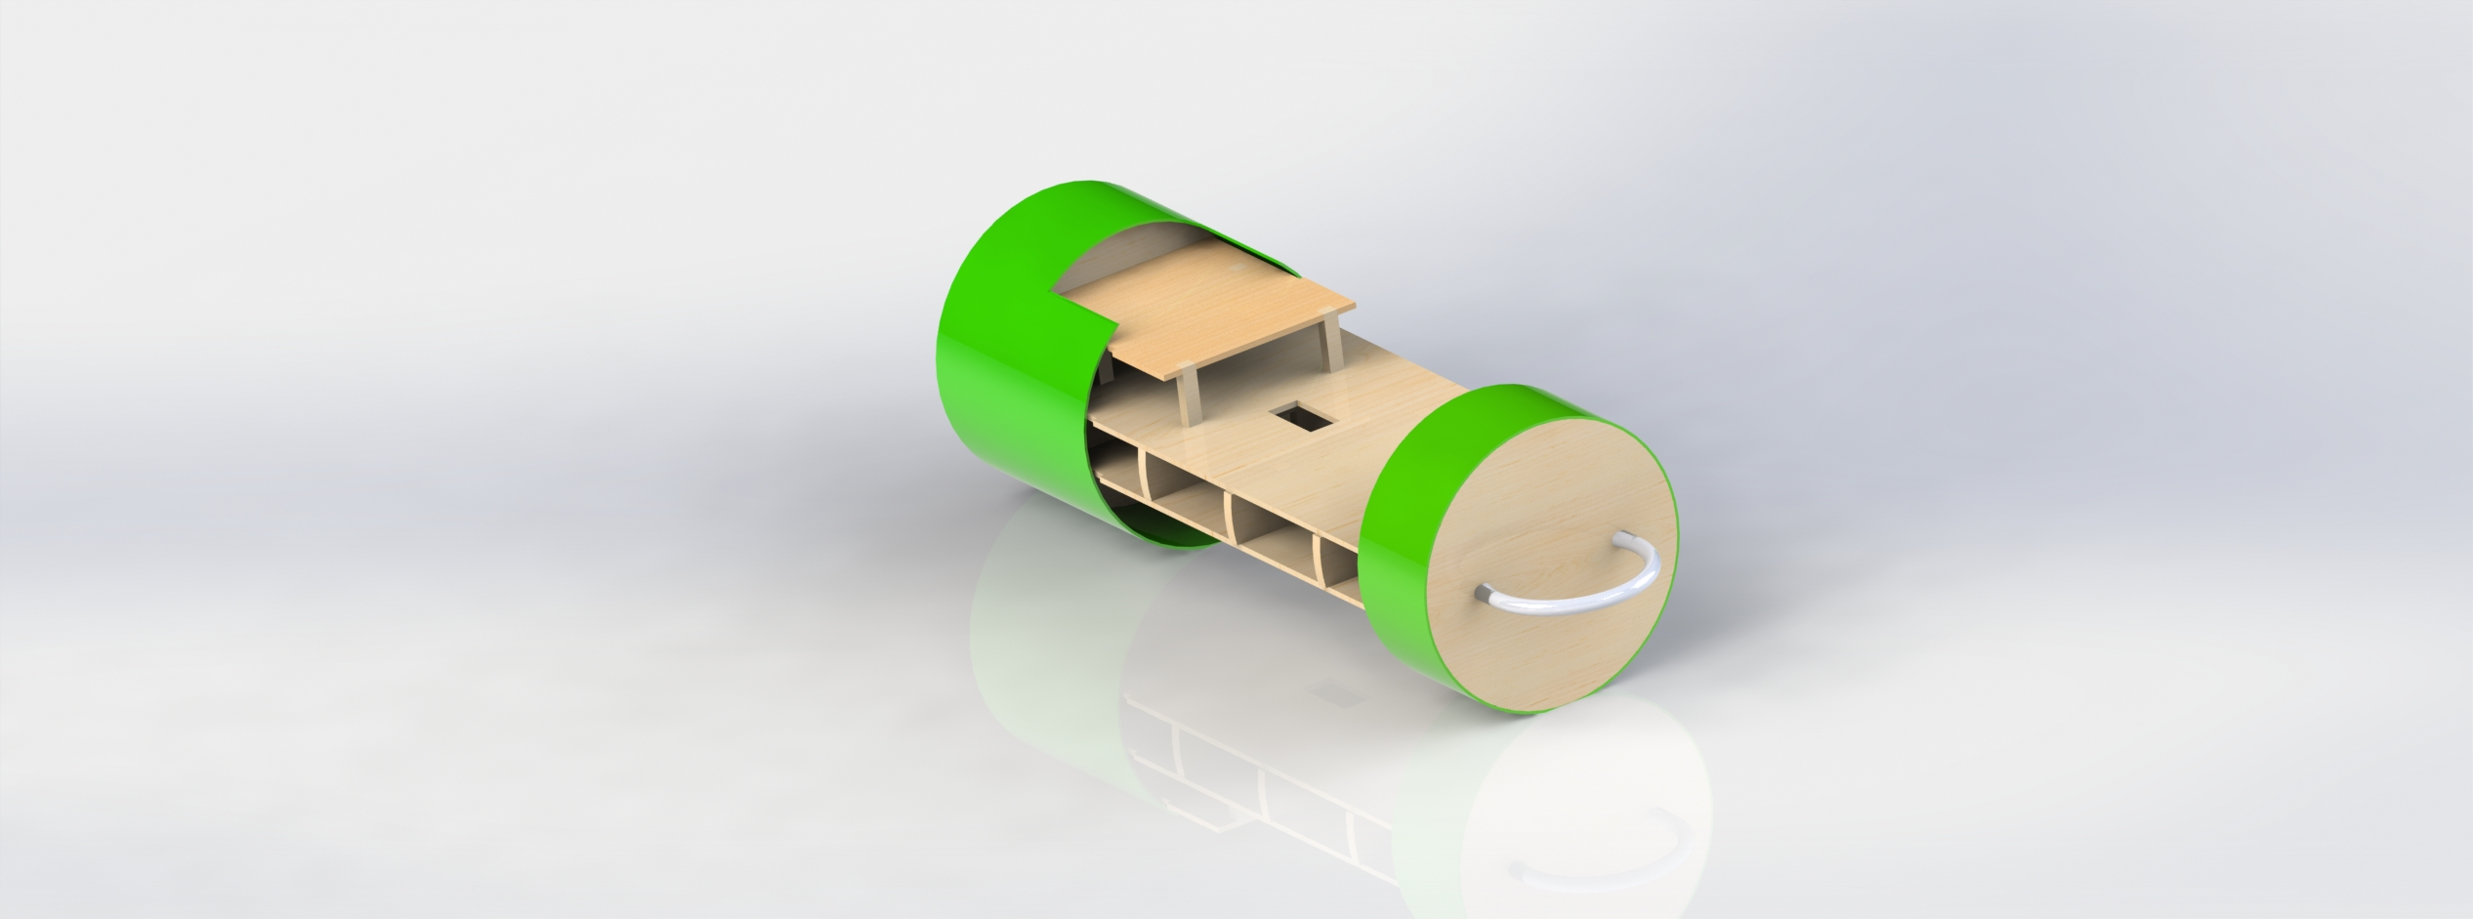
Figure 4: E-bay concept (12” sleds, 16” overall length)
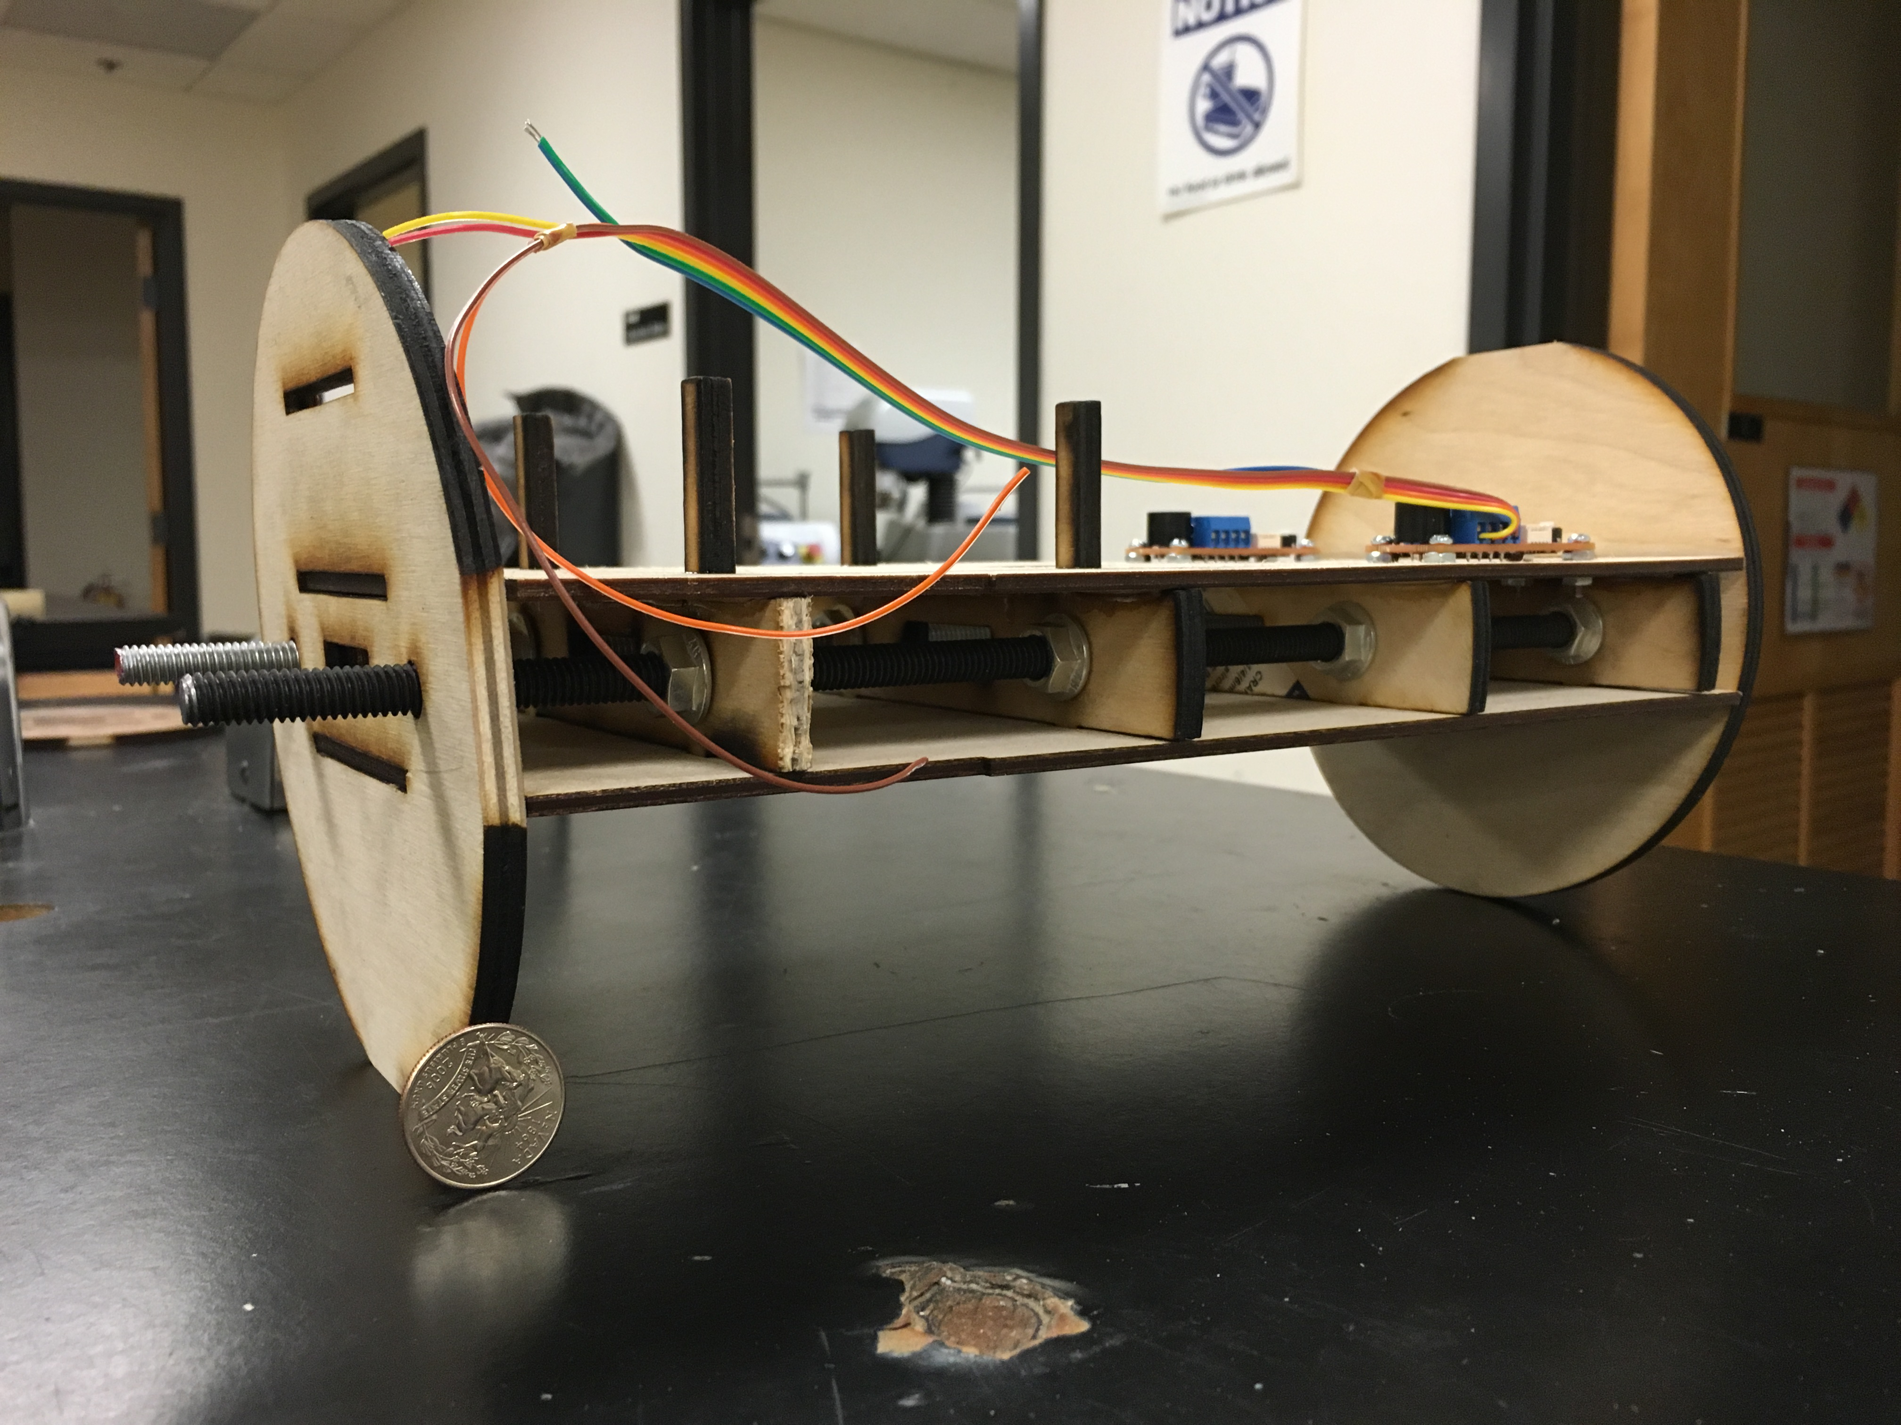
Figure 5: E-bay fabrication
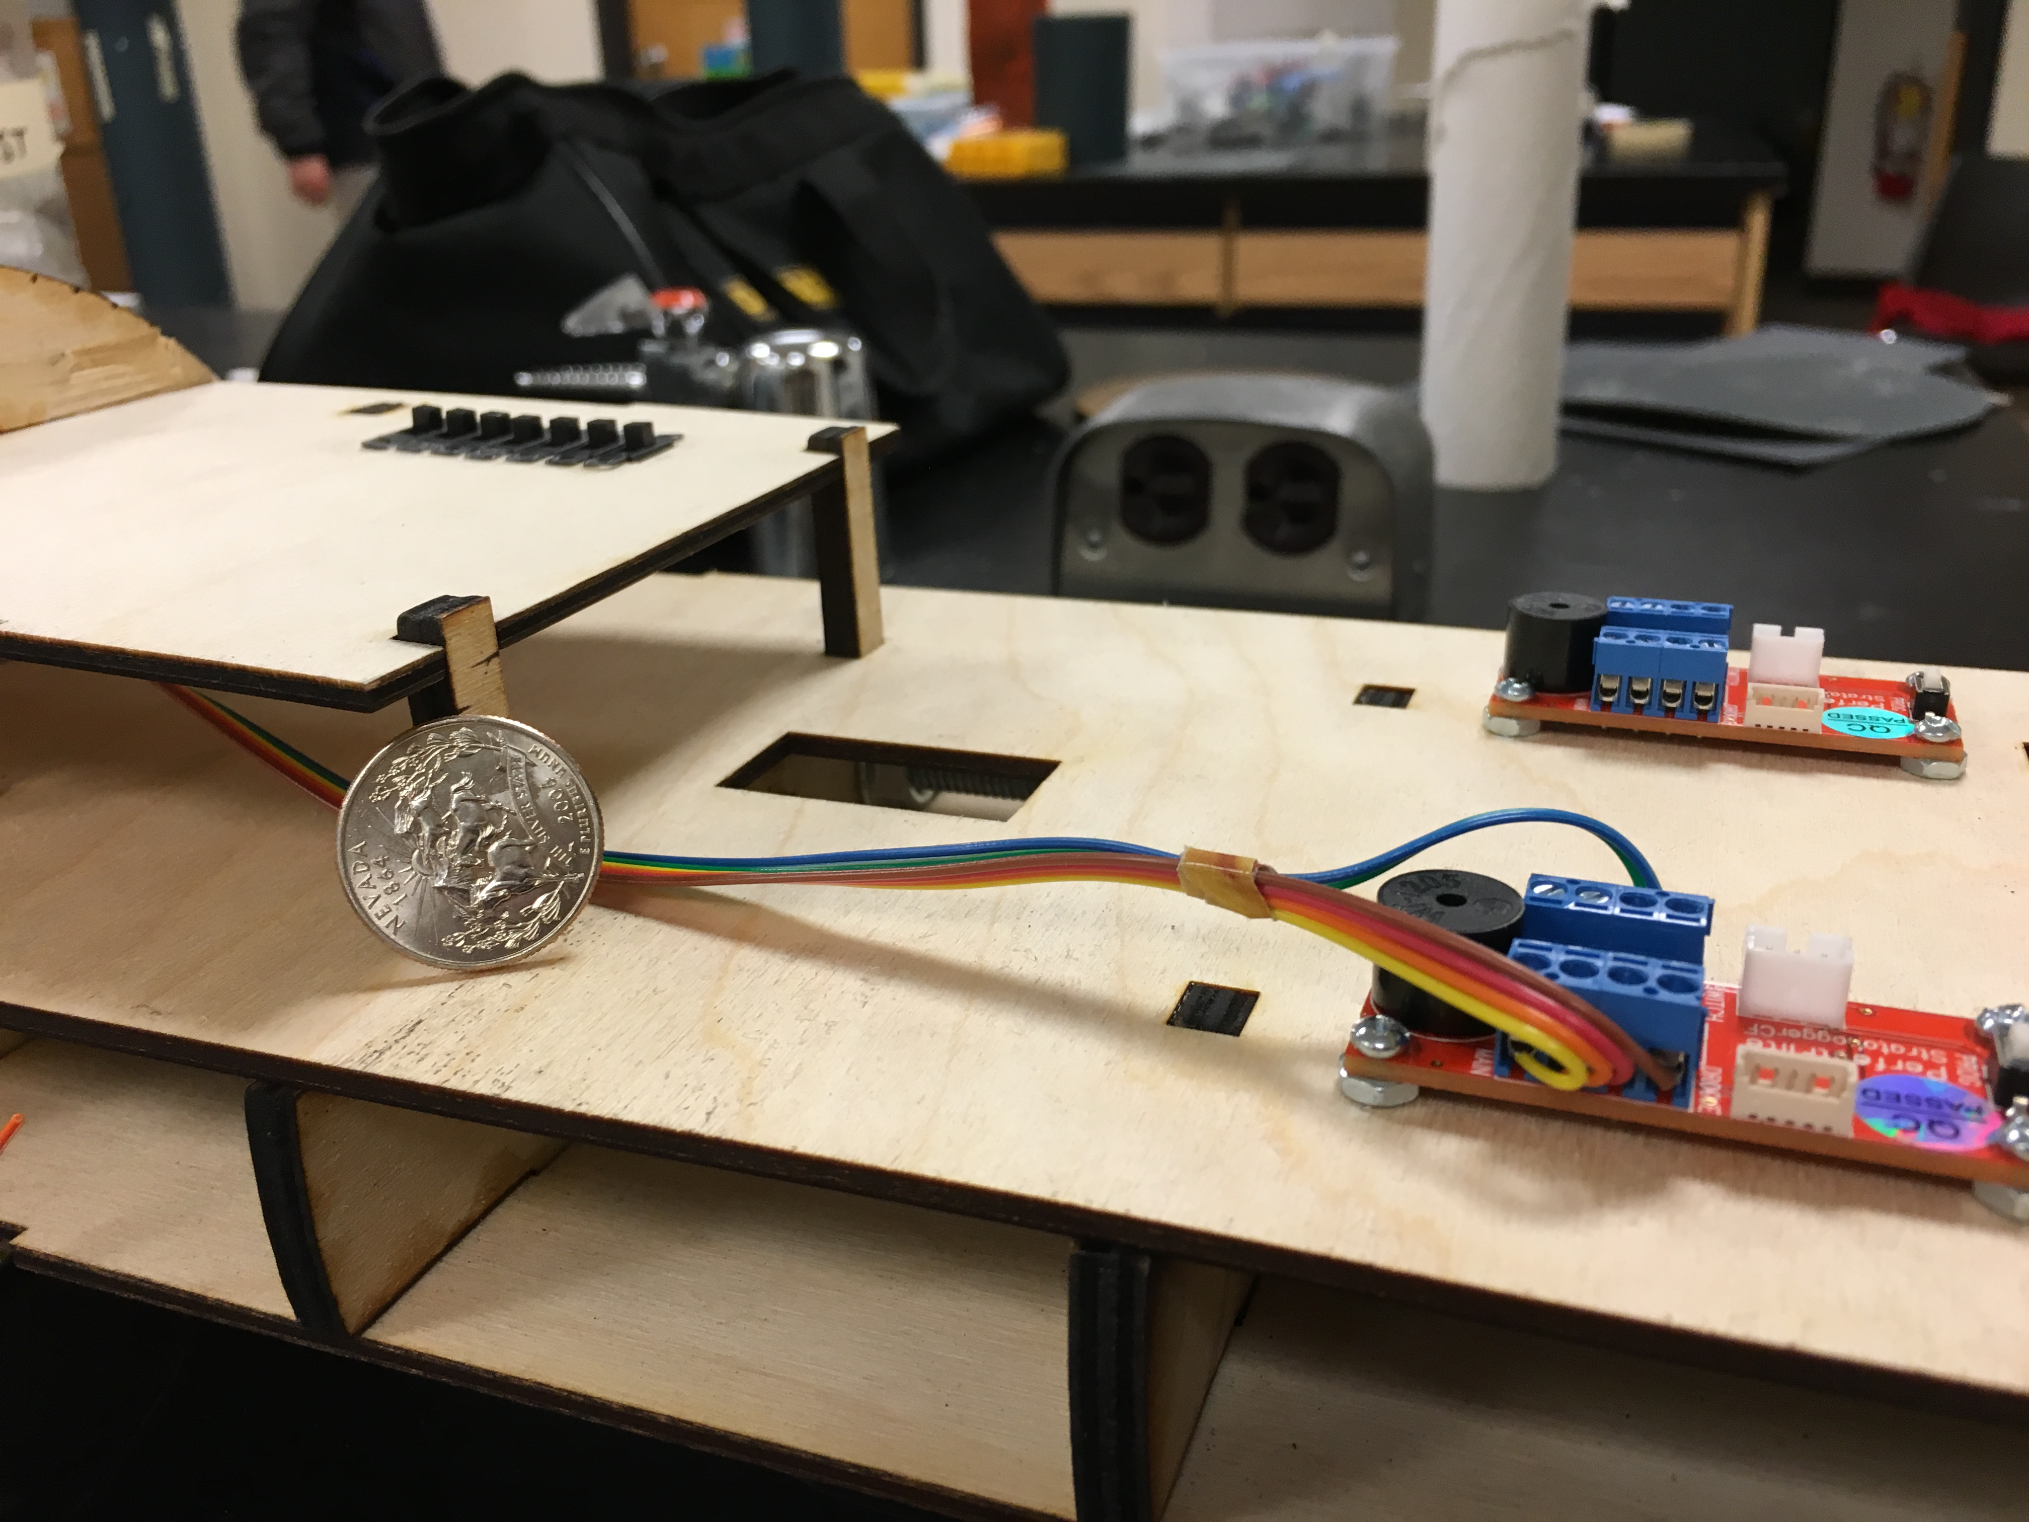
Figure 6: Flight computer mounted, as well as switch assembly

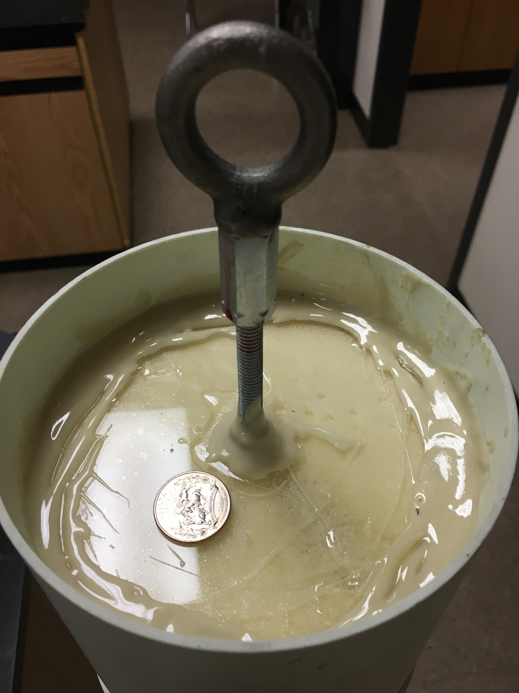
Figure 7: Shock chord attachment node on the aft of the nosecone

The middle portion of the airframe contains the e-bay and segments for drogue and main parachute bays. Continuing from the aft of the rocket, the other end of the shock chord connects via a swivel and a quick link (each with an 800lb capacity) to a 3” galvanized steel 5/16-18 U bolt connected to the e-bay. The U bolt is connected via thread locked couplers to two lengths of 5/16-18 threaded rod (the same as used in the aft section) each 15” long. The other end has the same setup with a 3” diameter 5/16 -18 galvanized steel U bolt connected to the threaded rods with couplers that are thread locked in place. The upper U bolt connects via a quick link and swivel to the main parachute’s shock chord. In between the U-bolts, a 12” e-bay is attached to the threaded rods with flanged nuts. The e-bay design is shown in figure, and allows for nearly 150 square inches of useable mounting space, and allows for easy access of the electronics without needing to remove the sled from body tube coupler. Two body tube couplers are secured via ¼” plywood bulkheads to the e-bay on either end (near the U bolts) and serve as mounting locations for the e-bay. When the e-bay is inserted into the airframe, four 3/8 x 4-40 screws are threaded into each section of blue tube coupler, positively securing the e-bay into place in the rocket. The e-bay section is also equipped with a removable access hatch that mounts on a cutaway section of the blue tube coupler, allowing quick and secure access to the e-bay switches prior to flight. The 6” blue tube hatch is then attached with two 4-40 screws to the coupler prior to flight.
The main chute is attached 1/3 of the way up the forward shock chord as to prevent the nosecone from contacting the middle airframe during decent. The forward shock chord attaches to an eyebolt on the nosecone via another swivel and quick link. The eyebolt is connected to a threaded rod via a coupler and thread lock and epoxied into place. The eyebolt is positioned at the very top of the nosecone coupler as to prevent the shock chord from swinging around and zippering the fiberglass nosecone shoulder. The threaded rod itself has several large washers on the forward end of it that are secured with flanged nuts and sit in the very front of the nosecone. The rod and washers were epoxied into place with ample amounts of rocket epoxy and left to cure for a full 24 hours (the inner sides of the nosecone were also scored with a knife to add surface area and aid to the adhesion of the epoxy). The rest of the 36 inches of nosecone and shoulder was then filled with 10:1 expanding foam to prevent the threaded rod from moving around in the nosecone. At the bottom of the nosecone where the eyebolt is, an acrylic centering ring was secured into the airframe with Rocket epoxy (as well as covering the surface to provide extra strength to the acrylic to prevent cracking). The centering ring ensured that the threaded rod was centered while the foam was expanding, and also provides some additional support to the rod where the eyebolt connects. Four #6 screws attach the nosecone to the shoulder, along with a healthy fillet of Rocket epoxy.
Rocket Recovery Systems Package

Deployment:

Black powder calculated using ideal gas equation:
$$m=\frac{PV}{RT}$$

Where m is the mass of black powder in grams, P is desired pressure calculated from desired ejection force (P = F/A), R as ideal gas constant of black powder, and T as the ignition temperature of the powder (1873k)

Drogue Deployment:
Drogue bay volume: 6” D x 15” = 424 in³
Deployment force desired: 350 lbs
Mass of black powder: 2.5g
Main Deployment:
Main bay by volume: 6” D x 17” = 480 in³
Deployment force desired: 350
Mass of black powder: 3g
Ground ejection tests for the drogue and main will occur prior to launch.
The nylon shock chords are protected with a nomex sleeve that fits around them next to the ejection system. Additional nomex blankets are used to protect the rest of the shock chord and parachutes.

Decent profile

Apogee:
At apogee the primary flight computer will ignite the primary black powder capsule for the drogue chute; the booster section will separate from the upper portion and the 18” drogue will be pulled out. Within two seconds of apogee the secondary flight computer will trigger the backup charge, exploding into the open airframe if the main charge fired and opened up the body.

Decent from apogee:
The rocket will fall quickly under the small drogue; this is a precaution to prevent substantial drift, and get the rocket back as quick as possible. During this time, it has a projected decent rate of 30 m/s for 70 seconds or so. The motor section was chosen to be deployed at apogee as the main source of decent drag from apogee is intended to be from the body itself, and separating the motor segment will be chaotic due to the aerodynamic fins catching the air on the way down.

Main deployment:
At 800 feet above the ground, the primary flight computer will fire off the first black powder charge in the main payload section; deploying the main parachute. At 700 feet the backup flight computer will fire off a secondary black powder charge that serves as the backup main deployment mechanism. The main will bring the rocket down to a velocity of 8 m/s (26 f/s) for touchdown.
The deceleration between 30 m/s to 8 m/s is where the extreme forces of the launch come into play. Deceleration in the neighborhood of 13gs are expected during this time, producing close to 1500N of force (340 lbs). With the advanced construction methods of the steel rods connecting the shock chords, the rocket is expected to withstand at least 800 lbs of force, which is the lowest of the UTSs of all of the connection points (specifically the quick link UTS of 800 lbs).
The 5/16 threaded rod is black oxide ASTM A193 Grade B7 Steel that is able to withstand maximum tensile strengths of 124,000 psi, meaning that it has a yield strength of 9510 lbs, much greater than is expected with recovery stresses.
Electronics
The flight computers are PerfectFlisht StratoLoggers that sense acceleration and barometric pressure to detect deployment events and ignite charges. Three 1/4 “ holes are drilled in a triangular pattern around the e-bay allowing the pressure inside to equalize and let the flight computers get atmospheric readings. The StratoLoggers are affixed to the 1/8th inch wooden sled by nylon standoffs
Each drogue and main charge is wired through the e-bay to a terminal block on the outer surface of the e-bay bulkhead. The terminal block is screwed into the bulkhead with a number 4 screw which is threaded into the wood, and an epoxy fillet is applied around the sides. An e-match is then connected to the terminal block and inserted into a PVC end cap ejection canister, which is screwed into the bulkhead as well. Both the drogue and main parachute bays have identical setups of two terminal blocks and two ejection caps.
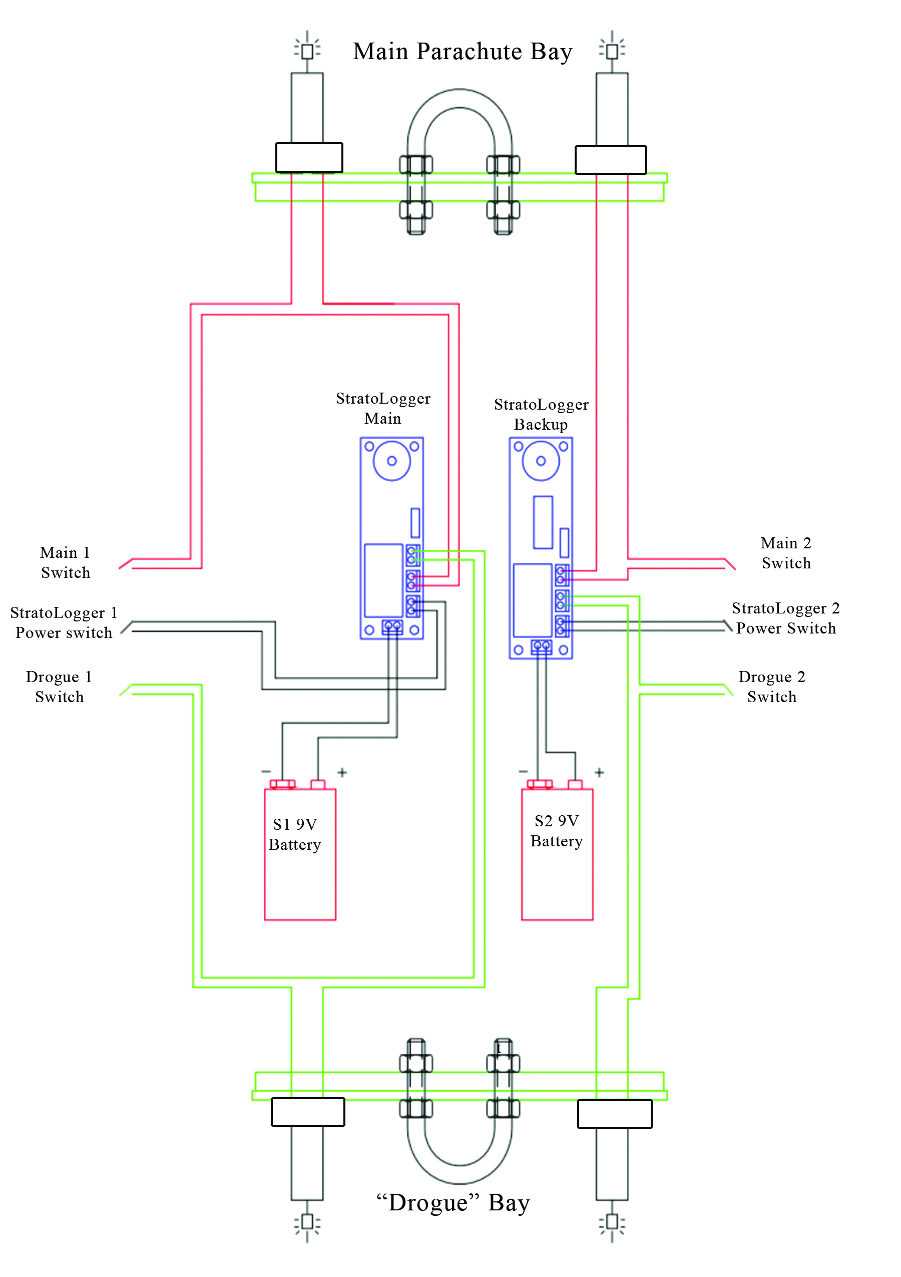
Figure 8: E-bay wiring diagram

Each set of wires going to the e-matches has a switch that has to be flipped to a closed state prior to flight. This switch ensures that there is a physical break between the pyrotechnics and the flight computers while staging the rocket. Prior to launch, when the rocket is on the pad, all four of the e-match switches are closed when the avionics systems are turned on.
Each flight computer has a separate 9V battery that is secured via mounting hardware to the electronics bay; making each flight computer completely independent. Each flight computer has a separate activation switch to turn them on prior to launch.
The switches used are just basic toggle switches that require substantial force on the small switch to flip. As a precaution, the on position is “down” when the rocket is oriented in flight configuration; that way, if the switches were to move due to the acceleration of the rocket, they would want to flip closed. Additionally a small locking arm is secured into place, that engages and locks all six of the switches.
All of the flight electronics and configurations have been used numerous times by myself and other members of my rocket club, leading to a reasonable currently of success. Additionally all of the ejection systems were ground tested prior to flight.
Additional:
Each separable segment is connected with 4 #2 nylon shear screws that are designed to break at 20 lbs of force. The screws prevent drag separations during ascent, and prevent the main parachute bay from opening up when the drogue is deployed.

Stability evaluation

The rocket is equipped with three rail buttons designed to fit into a 15x15 rail. The rail buttons straddle the center of mass of the rocket, with one on the middle portion of the motor section, and another on the lower portion of the upper section. This configuration ensures that the rocket is balanced on the pad, and will be stable leaving the rail.
The initial stability is calculated at 2.23 cal, which increased to just over 3.5 cal at motor burnout: 5 seconds after launch. A cal in this range will ensure that the rocket has a stable flight, although with a cal of 3.5 during flight, the rocket will have more of a tendency to turn into the wind, which can be beneficial as it will reduce the ground track distance from launch.
The center of pressure was calculate using the simulation program OpenRocket, and is located at 100 in from the nose or 28 in from the aft. With a cal of 2.23 in and a body tube diameter of 6 in, the aft is 13.4 in forward of the cp. The aft cg limit is six inches forward of the cp, locating it at a position of 94 in from the nose, or 34 in from the aft. The aft cg limit is six inches forward of the cp because it would give the rocket a cal of 1, which would be the lowest stability margin I would be comfortable launching this rocket. Prior to launch, the cg will be located by finding the balance point of the rocket; the point will be measured and check to ensure that it is forward of the aft cg limit. I have flown several rockets with stability margins in the range of 2 – 2.5 cal and they have demonstrated straight flights, giving them confidence that my cal of 2.3 will be sufficient.

Pre-launch

Equipment list:
- Motor
- Grains
- Inert motor casing
- Motor casing
- E-match (motor_
- #1 Philips screwdriver
- Small slotted screwdriver
- Small Phillips screwdriver
- Voltmeter
- Extra 6-32 screws
- Extra 2-56 nylon sheer screws
- 4 E-matches (ejection charges)
- Black powder measuring tool
- Black powder

Safety practices

Rocket preparation begins with the e-bay removed from the rocket, and each piece disassembled. The switch board will have all switches set to off; the Strataloguers themselves will be off, and the connections to each e-match will be broken. The correct amount of black powder will be measured out, and poured into the blast caps. An e-match will be placed on top of the black powder (on top ensures complete burning during detonation), and then a small wad of a tissue will be placed on top to keep the black powder packed. Each blast cap will then be covered with asking tape to ensure that the black powder does not come out in flight.
Once all of the ejection charges are loaded, two new 9V batteries will be placed into the battery receptacles, and the entire e-bay will be loaded into the rocket. The two sets of four setscrews will be screwed into wither end of the e-bay to hold it in place.
Once the e-bay is in place, the parachutes and shock chord can be packed in the rocket; before that can happen however, the fully assembled motor has to be inserted and secured into place because the drogue shock chord eyebolt screws into the motor housing. The 60 in parachute is folded in thirds several times until it is a low profile and will not tangle during ejection. The shock chord is would in a clockwise counterclockwise pattern to allow for tangle free deployment. A piece of 18” Nomex is placed over the ejection caps, and cradles the nylon shock chord and parachute to shied them from the hot gasses. Once the parachutes are packed, the nosecone can be inserted, and the lower airframe attached; each section is held in with three sheer screws that have to be screwed in once the section holes are lined up.
At this point the rocket is ready to be brought out to the pad, and setup on the rail. Once the rocket is on the rail, the 7 switches on the e-bay can be switched on on via the access panel on the outside of the airframe. At this point all of the pyrotechnics are live, and the altimeters armed. The access hatch is then screwed into place with four 6-32 screws. An e-match is then inserted up into the end of the rocket until it stops, and wrapped through the ejection cap to keep it in place. The leads to the e-match are then clipped and wrapped around the alligator clip leads, and the test button is pushed for a continuity check. The rocket is not ready for launch all personnel are back at least 500 ft from the launch pad.

Post flight checklist

Once the rocket is located and recovered, post flight inspection will begin. An overall assessment of the outside of the rocket will determine any damage to the airframe. The first order of business will be to unscrew the access hatch and turn off the altimeters and break the connection to the ejection charges; incase some of them did not go off. Once off, peering down the rocket body will show whether or not the ejection charges have all deployed, and if not, the e-bay will be removed, and the pyrotechnics disarmed.

Contingency checklist

If a misfire occurs, we will wait 60 seconds before approaching the rocket, unless it CATOed, then we will approach with fire extinguishers. In the event of a launch abort, the e-match in the motor will be disconnected, and then the electronics turned off, and the rocket will be removed from the pad. Igniters will be removed from the e-bay, and the black powder will go back into storage. The 9V batteries will also be taken out of the rocket for reuse, and to prevent them from draining.
In the event of a crash, the rocket will be pulled out of the ground carefully, as there could be some battery acid from the 9V batteries. The pieces would be collected and stored for later inspection and investigation into the cause of the failure.

After the flight, the supplemental L3 form will be filled out for a successful L3 certification launch, or a failure sheet in the event of a launch failure.

